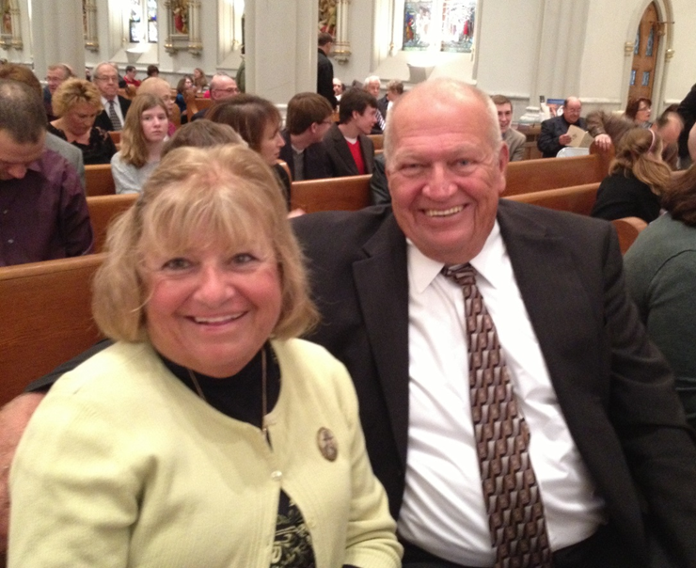Betty Howard Scholarship 2018 Application

The Betty Howard Scholarship is for reimbursement of exam fee to an individual for successful completion/passing of NCBDE Diabetes Educator exam.

Requirements:

* Member of WNYADE for one (1) year by application date: May 5, 2018
* Successful completion/passing of the NCBDE exam within 4/1/17 – 4/1/18
* Submit bio with application
* Submit a brief statement of how being a CDE within WNY will affect people with diabetes.
* Email submissions to [maryannegrady65@gmail.com](mailto:maryannegrady65@gmail.com)
* Scholarship Awarded at Annual Dinner –date/time TBD

Please Complete:

Name:_________________­­­­­­­­­__________________ Credentials:____________________

Date of CDE examination completion:_________________________________________

Phone # __________________________ This # is home, work, cell (please circle)

Email Address: ___________________________________________________________________

Submit this application, bio, statement of how being a CDE will affect people with diabetes in WNY, and documentation of CDE passing to Mary Anne Grady [maryannegrady65@gmail.com](mailto:maryannegrady65@gmail.com) by May 1, 2018.

Scholarship committee will meet and review the application and notify the 2018 recipient. The scholarship is awarded at the annual dinner.